Presenting Tab Changes
Pick List Changes
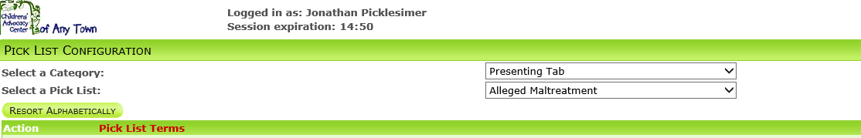

Tab | Pick List | Display Field | Matching Field | WVCAN/DJCS Definitions | WVCAN Excel Sheet
Presenting Tab | Alleged Maltreatment | CSEC | Sexual Abuse | #6 | Row 21
Presenting Tab | Alleged Maltreatment | Exposure to Pornography | Sexual Abuse | #6 | Row 22
Presenting Tab | Alleged Maltreatment | Depiction in Pornography | Sexual Abuse | #6 | Row 23

Forensic Interview Tab Changes
Data Entry Field Changes
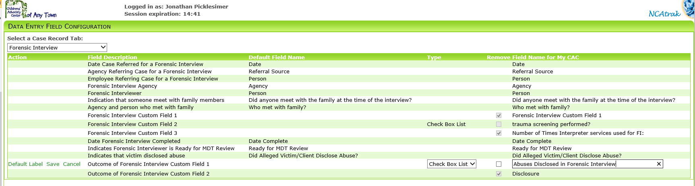
Pick List Changes
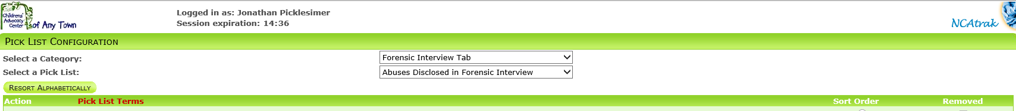
Tab | Pick List | Display Field | WVCAN/DJCS Definitions | WVCAN Excel Sheet
Forensic Interview Tab | Abuses Disclosed in Forensic Interview | Sexual Abuse | #8 | Row 27
Forensic Interview Tab | Abuses Disclosed in Forensic Interview | Physical Abuse | #8 | Row 28
Forensic Interview Tab | Abuses Disclosed in Forensic Interview | Drug Endangerment | #8 | Row 29
Forensic Interview Tab | Abuses Disclosed in Forensic Interview | Neglect | #8 | Row 30
Forensic Interview Tab | Abuses Disclosed in Forensic Interview | Witness to Violence | #8 | Row 31
Forensic Interview Tab | Abuses Disclosed in Forensic Interview | Commercial Sexual Exploitation | #8 | Row 32
Forensic Interview Tab | Abuses Disclosed in Forensic Interview | Exposure to Pornography | #8 | Row 33
Forensic Interview Tab | Abuses Disclosed in Forensic Interview | Depiction in Pornography | #8 | Row 34
Forensic Interview Tab | Abuses Disclosed in Forensic Interview | Other | #8 | Row 35
Forensic Interview Tab | Session Type | Extended Forensic Interview | #13 | Row 51

General Tab Changes
Date Entry Field Changes
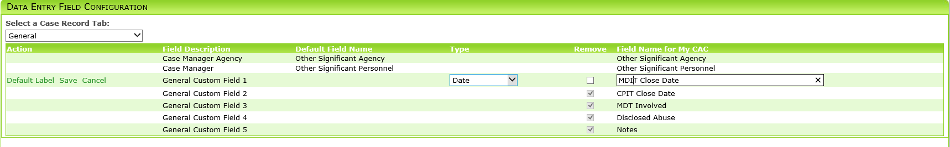
Pick List Changes
Tab | Pick List | Display Field | WVCAN/DJCS Definitions | WVCAN Excel Sheet
General | Case Close Reason | Unsubstantiated by Team Investigation | #21 | 59
General | Case Close Reason | Unprosecutable | #21 | 60
General | Case Close Reason | Alleged Offender Died | #21 | 61
General | Case Close Reason | Mentally Incompetent to Stand Trial | #21 | 62
General | Case Close Reason | Prosecution Refuses to Extradite | #21 | 63
General | Case Close Reason | Victim Unwilling to Proceed | #21 | 64
General | Case Close Reason | Other | #21 | 65

