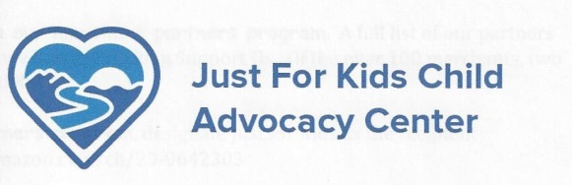
Serving children and families in Raleigh, Fayette and Wyoming Counties with the goal of preventing and responding to child abuse.

CHARITY GOLF TOURNAMENT
Friday, August 21th, 2020
Four Person Scramble
The Woodhaven Course at Glade Springs
12:00 p.m. Registration and lunch ~ Tee off at 1:00 p.m.

SPONSORSHIPS

TITLE SPONSOR
$5,000.00
PLATINUM ~ $2,000 GOLD ~ $1,000 Banner acknowledgement Banner acknowledgement
Newspaper, program listing, media mention Newspaper, program listing, media mention
Hole sign, and 2 Teams Hole sign, and 1 Team
SILVER ~ $500
Banner acknowledgement
Program Listing
Three flights: Men’s, Ladies and Mixed Teams

ENTRY FEE: $400.00 PER TEAM

___ I/my company would like to be a sponsor at the ____________ level
___ I/my company would like to be a sponsor at the ____________ level and register a team(s)
___ I/my company would like to register/enter (#) _________ team(s) in the tournament
Please complete the reverse side with team players’ names and email addresses

___ I/my company would like to sponsor a hole(s): #_____($125 per sign) TOTAL: __________
___ I/my company would like to contribute ________________ as a gift in kind for the auction

(To encourage more charitable giving in 2020, the recently enacted government stimulus bill (the "CARES Act") provides some additional tax relief for donors. This makes it easier to give and save at the same time. If you take the standard deduction on your 2020 tax return , you can claim a brand new "above-the-line" deduction of up to $300 for cash donations made to a charity this year.)
____ We are unable to participate in the tournament this year, but
would like to make a ____________ donation to Just for Kids, Inc.

NAME/COMPANY: _____________________________________________________________________________
ADDRESS:______________________________________________________STATE:________ZIP:__________
CONTACT NAME:____________________PHONE:_________________Email:________________________
CHECK(s) ENCLOSED:___________________ SEND INVOICE:__________________
Make Check payable to: Just For Kids, Inc., 129 Main St. Suite 406, Beckley, WV 25801
FOR QUESTIONS OR ADDITIONAL INFORMATION, CONTACT SCOTT MILLER
304-255-4834 justforkidswv@gmail.com

Just For Kids Child Advocacy Center is a 501 (c)(3) organization

