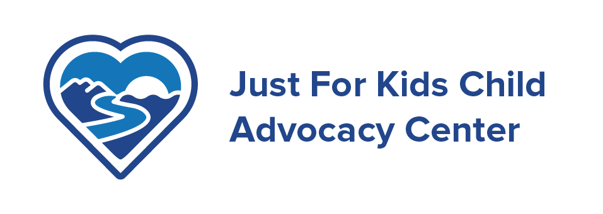

June 29. 2020

Mr. and Mrs. Smith
Beckley, WV 25801

Dear Mary and Sam,

Experts have sounded the alarm that COVID 19 has made our children more vulnerable to physical and sexual abuse. They are out of school, often their “safe place” where teachers and counselors are trained to spot the symptoms of a child suffering from abuse. They are socially isolated in their homes away from observant eyes.

During these challenging times, our dedicated staff has continued to support the children who have found ways to reach out to us. We already know that when children are able to return to school and engage in outside activities, our Child Advocacy Center will experience a surge of referrals. Our staff will be stretched to its fullest at a time when federal, state, and historic funding remain unpredictable.

These have been challenging times for us all; however your support will make a dramatic difference in our ability to provide the services our children and community expect and need. Just for Kids will continue to adapt our practices to assure that the children and families we serve, as well as our team members, stay safe and healthy.

Golf may be the ideal sport in this new environment we are all learning to live in. This year’s Just for Kids Charity Golf Tournament is one way you can make a difference for kids. This year’s Tournament will be held on Friday, August 21st at 1:00 p.m. on the Woodhaven Golf Course at Glade Springs. We want you to be part of it. The Tournament offers various Sponsorship opportunities, as well as several ways to contribute to the success of the event, such as team play, cash contributions, hole sponsorships, and gift donations for the raffle and silent auction following play. Tournament sponsorship at any level and the signage it provides is wonderful exposure for any business, and also serves as an introduction and/or reminder of your business to the more than 100 players that participate in this Tournament. The Tournament invitation sheet with the opportunities available for your participation is enclosed for your review.

We appreciate your past support and so hope we can count on your participation in this year’s Tournament. We know this year has been difficult for many businesses, but we look forward to hearing whether you can participate in any way this year. We are holding a team spot for your, so if you are not able to play this year, please let me know as soon as possible. Should you have any questions, please do not hesitate to call me.

Mary Smith
Member, Charity Golf Tournament

Attachments
Our mission is to create a safe community for children and families by preventing and responding to child abuse through teamwork, collaboration and services.
Just For Kids, Inc.
129 Main St. Suite 406,
Beckley, WV 25801
304-255-4834
justforkidswv@gmail.com

Just For Kids Child Advocacy Center is a 501 (c)(3) organization

