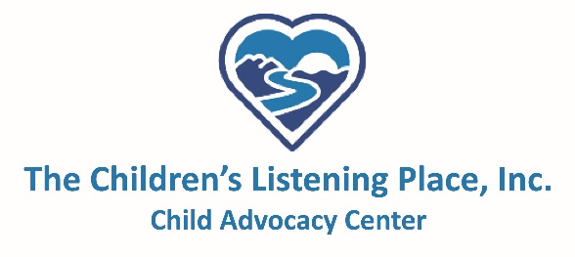

Medical Program Cost Breakdown

Description | Cost | Average Per Year | Estimated Yearly Cost
SANE Call-Out | $ 300 | 20 | $6,000
MDT Meetings (5 counties) | $ 250 | 12 | $3,000
Court Appearances | $50 | 4 | $200
SANE Continuing Education Training | $1000 | 1 | $1000
Medical Camera Annual Maintenance Fee | $2000 | 1 | $2000
Medical Supplies (latex gloves, medical gowns, etc.) | $2500 | 1 | $2500
Proactive/Prevention Program (brochures, pencils, bracelets, etc.) | $2500 | 1 | $2500
TOTAL COST OF MEDICAL PROGRAM: |  |  | $17,200

