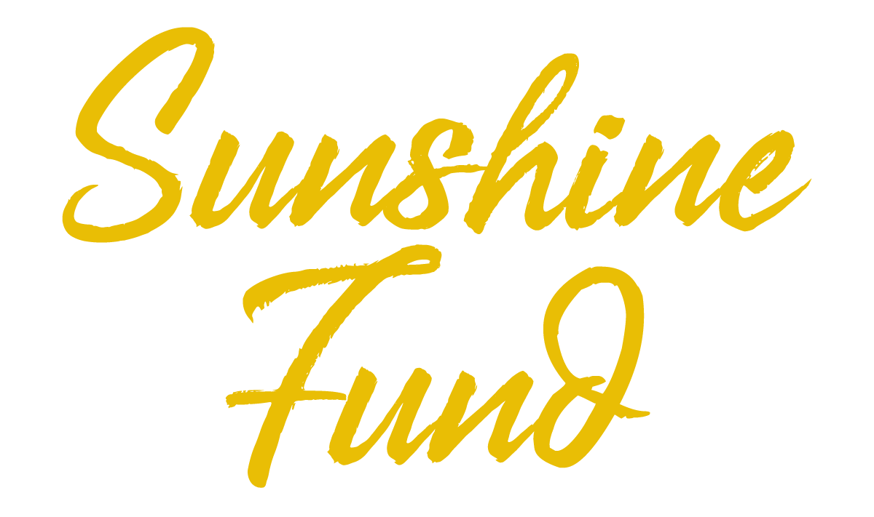

WVCAN Sunshine Fund FY24 Application

Date of Request:

Applicant First & Last Name:

Child Advocacy Center Name:

Amount of Request (up to $1,000):

If application is accepted, would you be willing to provide photos/narrative of project outcome? (Yes/No; answer does not affect acceptance of application):

Do we have your permission to share your proposal with funder partners for potential direct sponsorship? (If yes, publicity will likely be requested.)

Description of Planned Project:

If you received a FY23 Sunshine Fund mini-grant, please share a little about how that grant helped your staff and/or team(s) in your mission work. (Feel free to attach pictures with your application so WVCAN can share online or directly with funders to show them the incredible impact their contributions are making!)

Submit to Kate Flack (kate@wvcan.org). Applications will be accepted and considered on a rolling basis until May 24, 2024. CACs may only apply for one Sunshine Fund mini-grant per year, but that does not preclude you from applying for emergency funding per WVCAN’s Emergency Funding Policy & Form available on the Local Center Resources page of WVCAN’s website.

