

CAC WordPress User Guide

Table of Contents
The Proof team is on hand if you have any technical questions. Email us at hello@proofbranding.com and we’ll be happy to help guide you through any WordPress problem.

- Getting Started
  - The WordPress Dashboard
    - Login to WordPress
    - Dashboard Menu
  - Website Navigation Menu
- Building Pages with Blocks
  - Understanding Blocks
  - Adding and Removing Blocks
  - Block 1: Hero (non-homepage)
  - Block 2: Hero with Video (homepage)
  - Block 3: Text Content
  - Block 4: CTA
  - Block 5: Text & Image
  - Block 6: Text & Image ALT
  - Block 7: Image Fullwidth
  - Block 8: Event
  - Block 9: Video
  - Block 10: Accordion
  - Block 11: Column (2, 3, 4, repeating)
  - Block 12: Contact
  - Block 13: Team
- Modifiers: Custom Classes
- Content Syling

Getting Started
This guide focuses on the particularities of your CAC’s website. If you would like more information on the basics of using WordPress - the platform on which it is built - please visit our user guide site at https://wpguide.proofbranding.com/.

The WordPress Dashboard

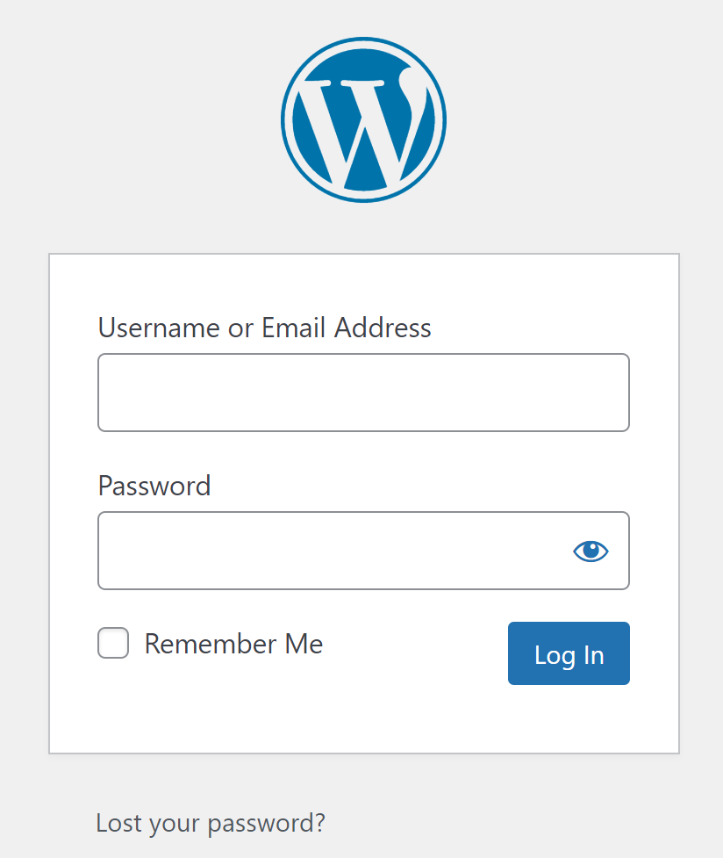
Login to WordPress
Your WordPress dashboard can be found at https://mercerchildprotect.com/wp-login.php. The login screen asks for your username and password, with the option to reset your password if you have lost it.

We recommend only giving login details to people who will administer the website or edit content. All other users (e.g. subscribers and Authors) should not be given access, for security reasons.

For added security, please do not change your password to something easy to remember. WordPress recommends very complex passwords to help prevent hackers from accessing your website. If you forget your password, you can generate an equally secure one by clicking the “lost your password?” hyperlink. You will receive it via email.

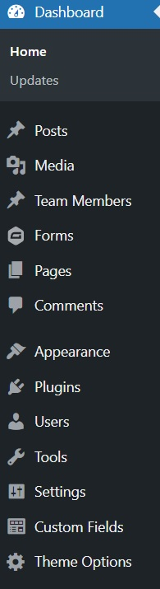
Dashboard Menu
When you first log in to the WordPress dashboard, you will see a menu like the one on the left. As an editor, you’ll mostly be interested in:

Posts - allows you to add new posts to the blog section of your website (if applicable).

Media - allows you to upload media assets (pictures, videos, PDF files, etc.) to your server. Once uploaded to the server, a special link will be created for each media item. You can add files to the website via the Media menu item or directly when editing a page or post.

Team Members - each team member has their own mini-page. To add a new team member, simply click the Team Members menu item and then click on add new. Don’t forget to select the group (on the right, underneath publish).

Forms - this item connect you to the GravityForms plug-in that we used to create your contact form. You can create new forms yourself or drop us a line and ask us to do it for you.

Pages - your website’s pages will be stored in the Pages section. You will learn how to add and edit pages by reading this guide.

Appearance - within the Appearance section, you should only need to edit Menus and widgets. Please do not use the Theme Editor unless you are experienced with editing WordPress code.

All the other windows accessible from the Dashboard menu are only needed by Administrators to add functionality to the website, add or remove Users, and make software updates. If you have a maintenance retainer with Proof, we’ll handle all of these administrative tasks as part of our agreement.

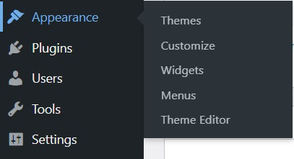
Website Navigation Menu
To change your website’s navigation menu (the classic menu tab that’s displayed on all pages), access the Appearance tab and click on Menus. From the Pages section (left), you can choose to add new items to the menu, and from the Menu Structure (right) section you can reorder the pages as needed (add as a subpage underneath a parent page or as a standalone page).

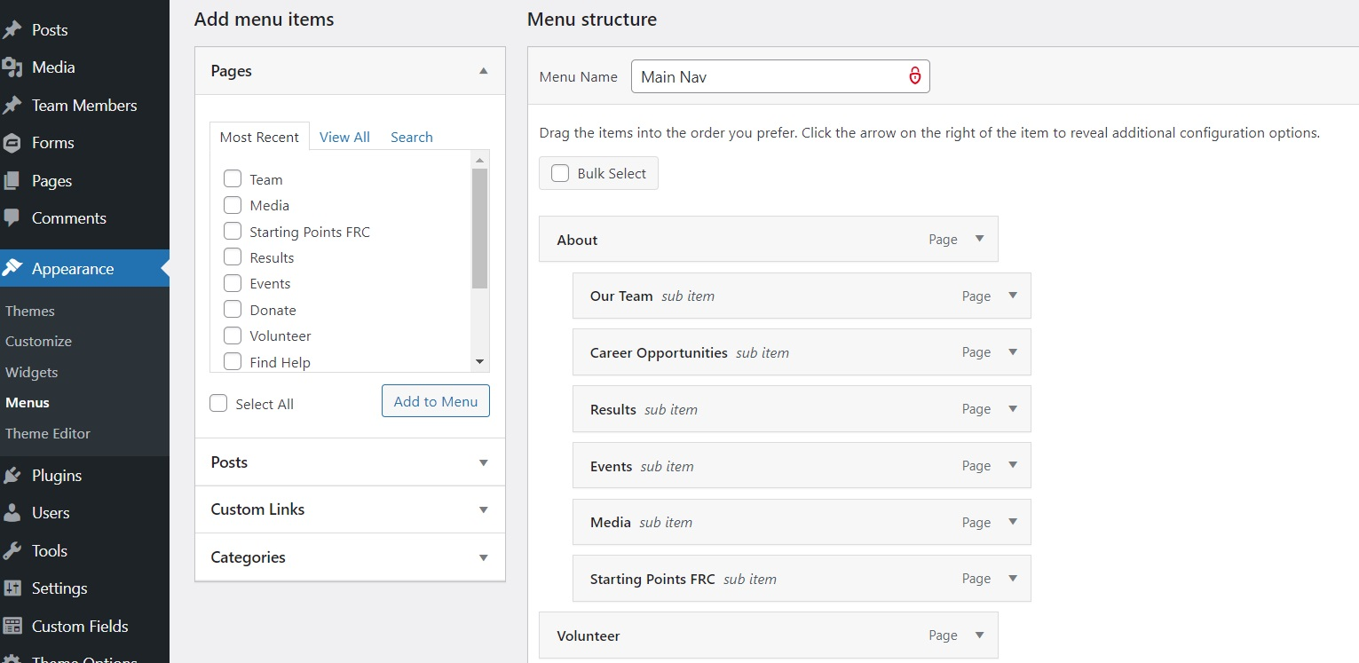

Website Navigation Menu



Building Pages with Blocks

Understanding Blocks
Each page of your website is built using several templates mashed up together to create a unique layout. We call these templates blocks and in this section we’ll teach you how to create new pages using the pre-existing blocks we designed and coded for your convenience.

Note that blocks are only used on pages that use the page builder template. They do not apply to Posts or Team Members. Make sure that when you add a new page to the website, you select the blocks page builder template.

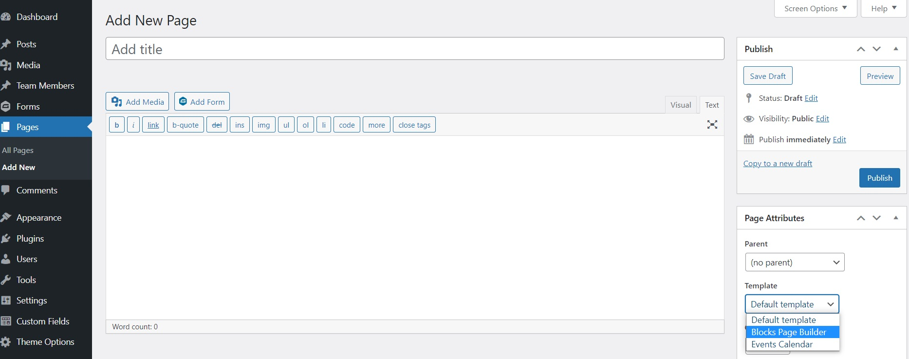

When adding content to your blocks, make sure to use the text edit mode and not the visual edit one. To switch, simply click the text button in the upper right corner of the text box.

Pro tip: blocks can be duplicated (hover across the block, check the top-right icons), so make sure to use this feature when adding repetitive or complex blocks. You can also copy-paste the content of an existing block that you want to replicate and adjust the content as needed.

To understand how we use blocks to design the layout of your website, let’s take a look at the homepage.

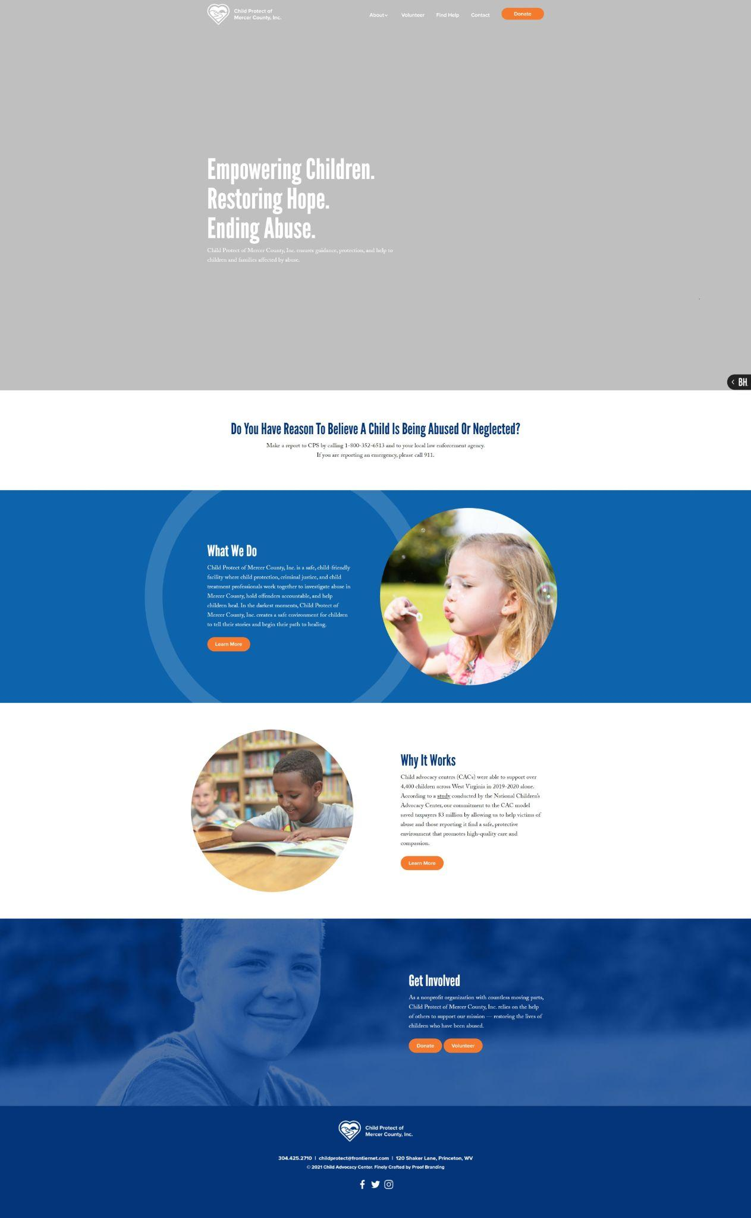

hero block

block 1

block 2

block 3

block 4

footer

The homepage is broken down into several blocks. First, there’s the hero block with a looping video (not seen here). Then, block 1 is a simple text block with a call to action. Block 2 has text + image, as does block 3. Block 4 has an image as background, and is followed by the footer.

Now, if you look in the WordPress dashboard (pages -> homepage) you’ll se the blocks that we used to lay out the homepage.
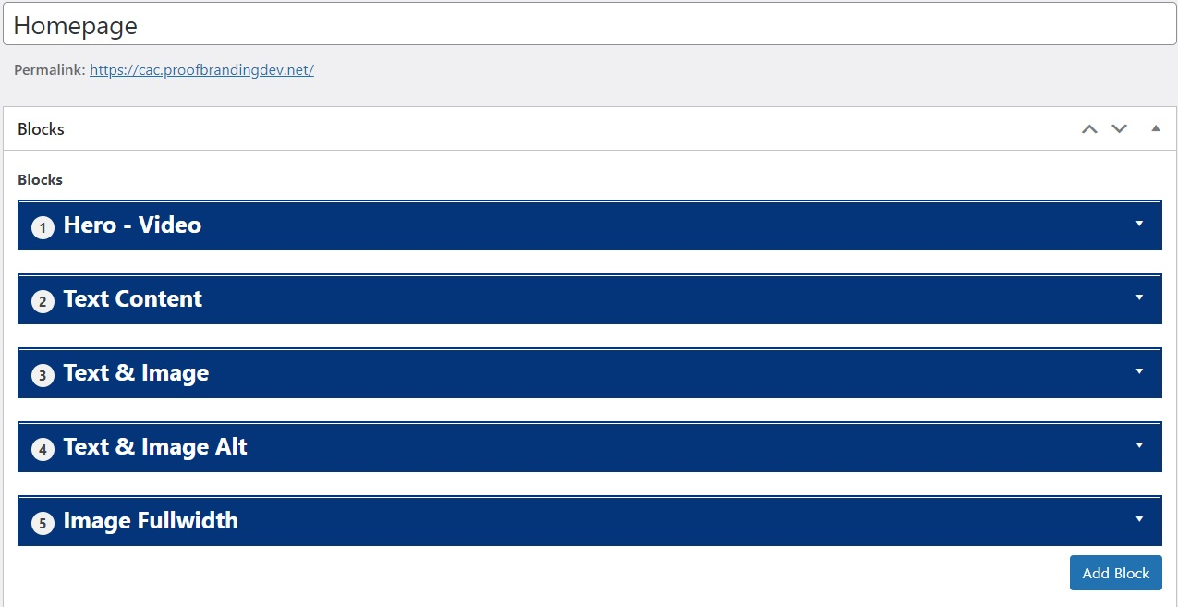

hero block

block 1

block 2

block 3

block 4

By using the block builder, you can create new pages, edit existing ones, and organize your content in a way that suits the needs of your CAC. Each block can also be personalized further using modifiers called classes - you can use them to add background elements (such as the circle in block 2), add or remove margin space (something called padding), align the text in a certain way, and more. We’ll tell you about them later.
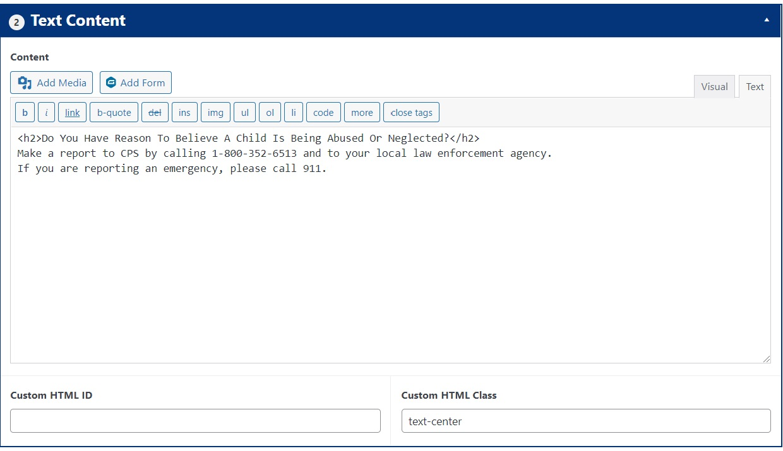
This is how a block looks like in the dashboard. You can add media items, text, and modifiers (classes) as needed.

Adding and Removing Blocks
New blocks can be added to a page by clicking on the blue add block button at the bottom of the page. This will open a menu where you can choose which type of block to add. Blocks have a drag and drop functionality which allows you to reorder them as needed.
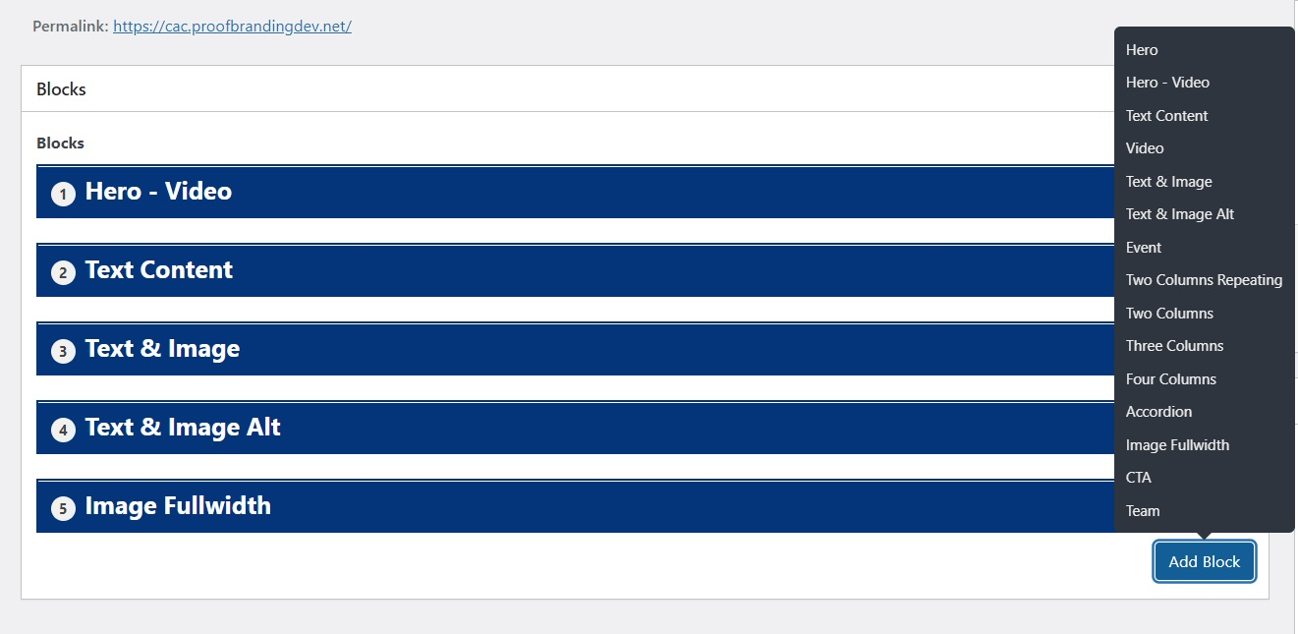
As you can see, you can choose from 15 blocks when creating or editing pages. We’ll go over them shortly.

To remove a block, hover your mouse over it and click the first icon from the right.
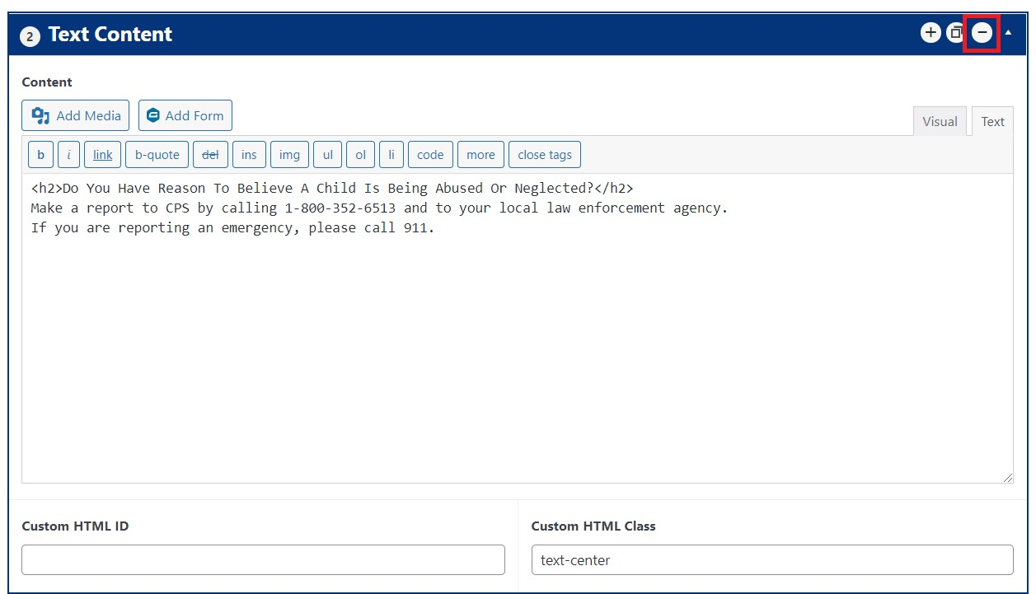

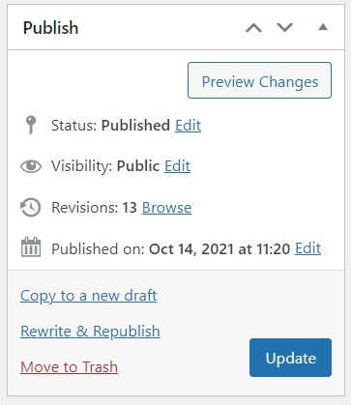
Make sure to click update once you finish making your changes.

Note that once you update the page, this cannot be undone without rolling back the page to a previous version or restoring the site from a backup. So be careful when removing blocks!

A good rule of thumb is clicking preview changes before updating, just to make sure things look as intended. This will allow you to keep making changes without losing the existing page set-up. Once you’re happy with how it looks, you can go ahead and click update.

Block 1: Hero (non-homepage)
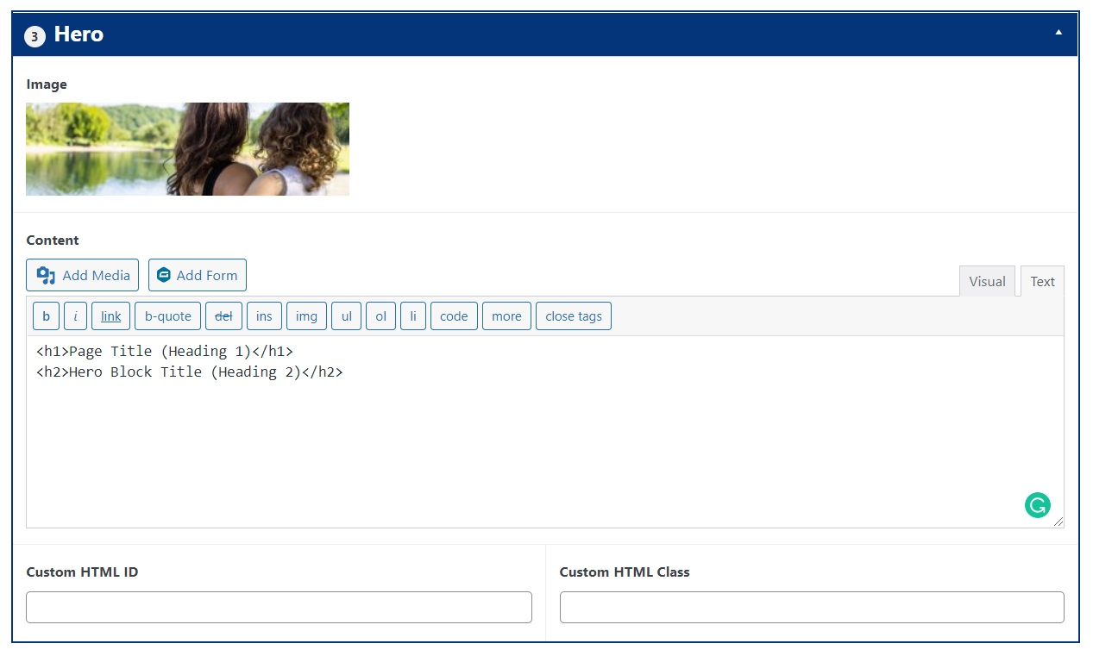
Dashboard View

This is the standard hero block used throughout the website. It works for all pages except the homepage.

Image - the added image will display as a background. Size should be 2560x750px.

Text - <h1> and <h2> are text heading tags. they modify the size and appearance of the text. use <h1></h1> when mentioning the page name on the hero. for the subheading, use <h2></h2>.


Frontend View

Block 2: Hero with Video (homepage)
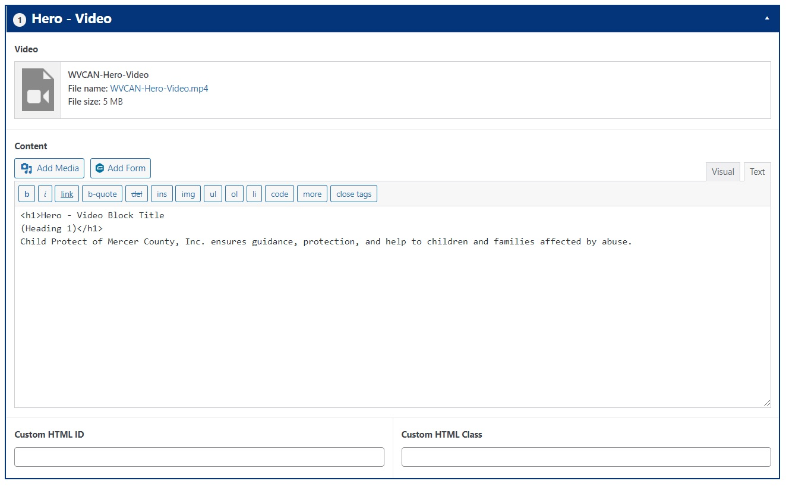
Dashboard View

This block is similar to the standard Hero block, but instead of an image, it adds a looping video in the background. To add a new video, click add media and upload your file.

Text styling is also different. Here, the <h1> tag highlights the biggest text on the block. There are no subheadings, and the body text doesn’t need additional tags (it’s styled by default).

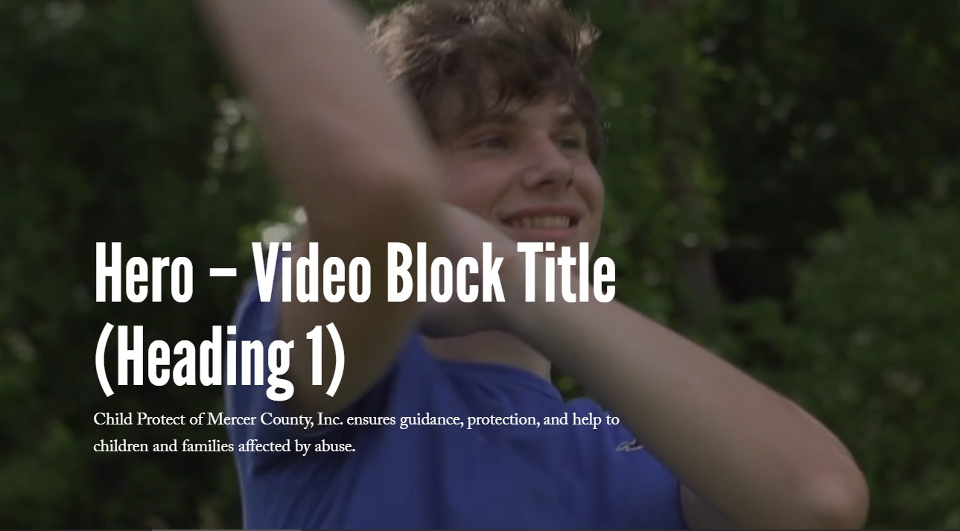
Frontend View

Block 3: Text Content
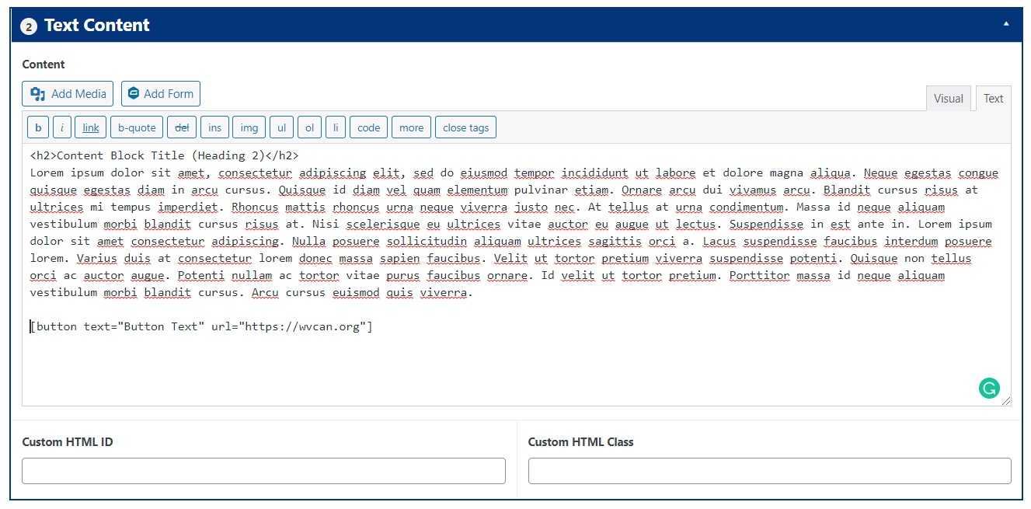

The text block is one of the simplest blocks to master. All you have to do is use a subheading using the <h2> tag and add the copy below. You can add bigger text breaks (spaces) between paragraphs by using the <br> tag.

To add a button, copy-paste the following snippet within the text box: [button text="Button Text" url="destination URL goes here"]

You can change the background color of the block by using modifiers (classes).

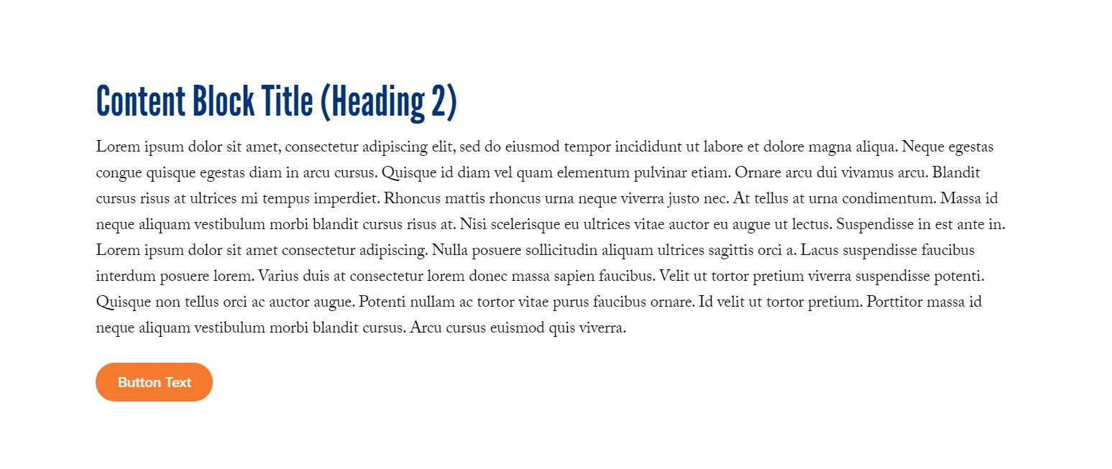
Frontend View

Block 4: CTA
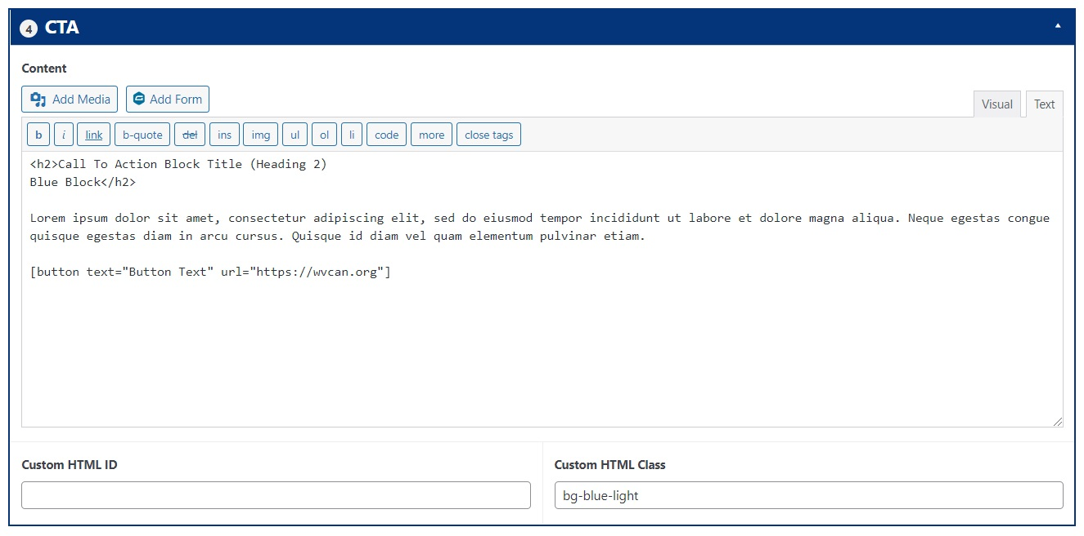
Dashboard View

The CTA block is ideal for when you want to call attention to a certain message. As with the text content block, use an <h2> for the title and the snippet for adding a button.
To change the background you can use modifiers (classes). In this example, we used a light blue background instead of a white one. We used the class “bg-light-blue”, with bg standing for background.

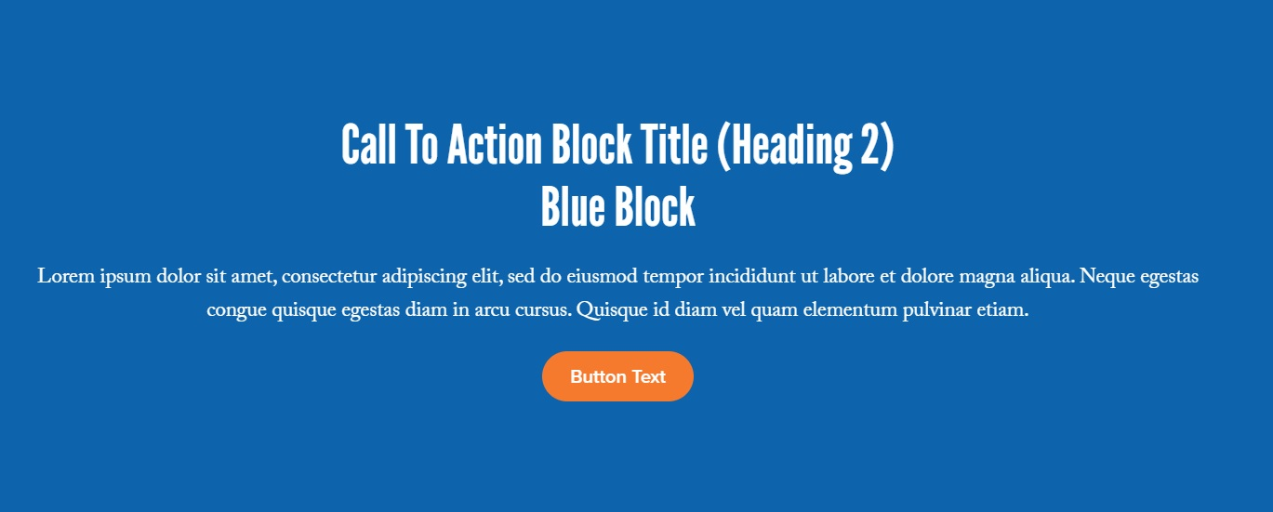
Frontend View

Block 5: Text & Image
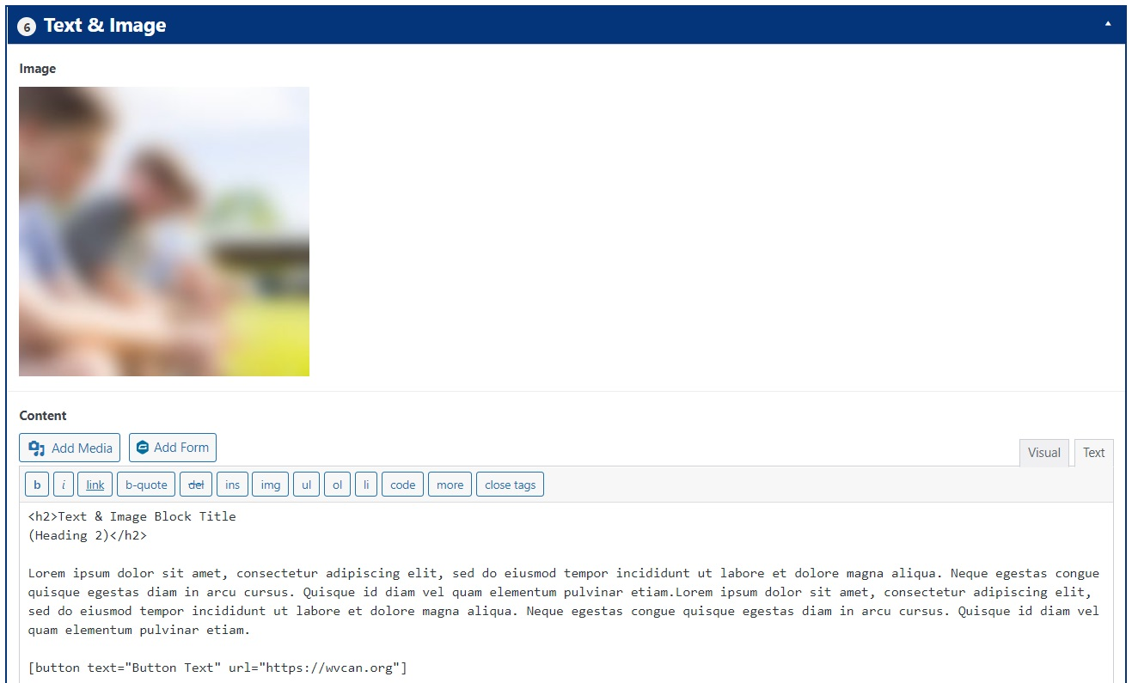
Dashboard View

This block allows you to add an image alongside the text body, displayed on the left. Image size should be 1200x1200px. The background is blue and includes a circle.

To reverse the order (text on the left, image on the right), add the “reverse” modifier in the Custom HTML Class field (bottom right corner).

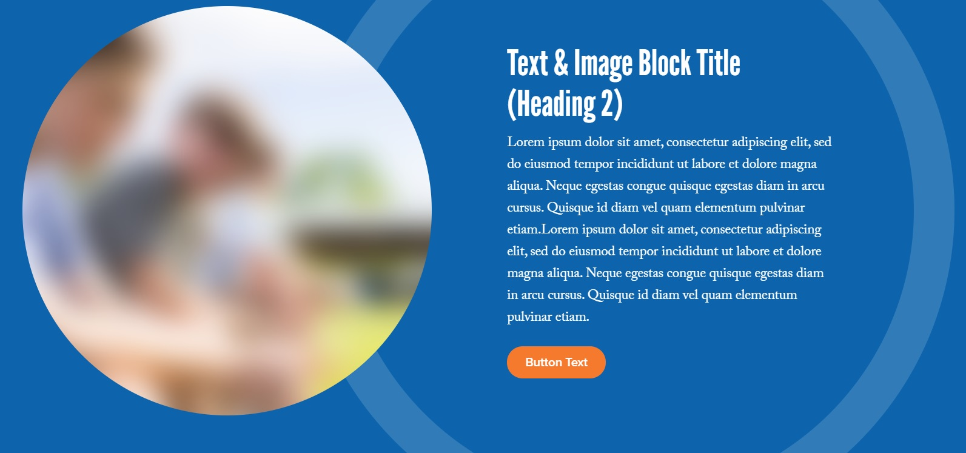
Frontend View - Standard

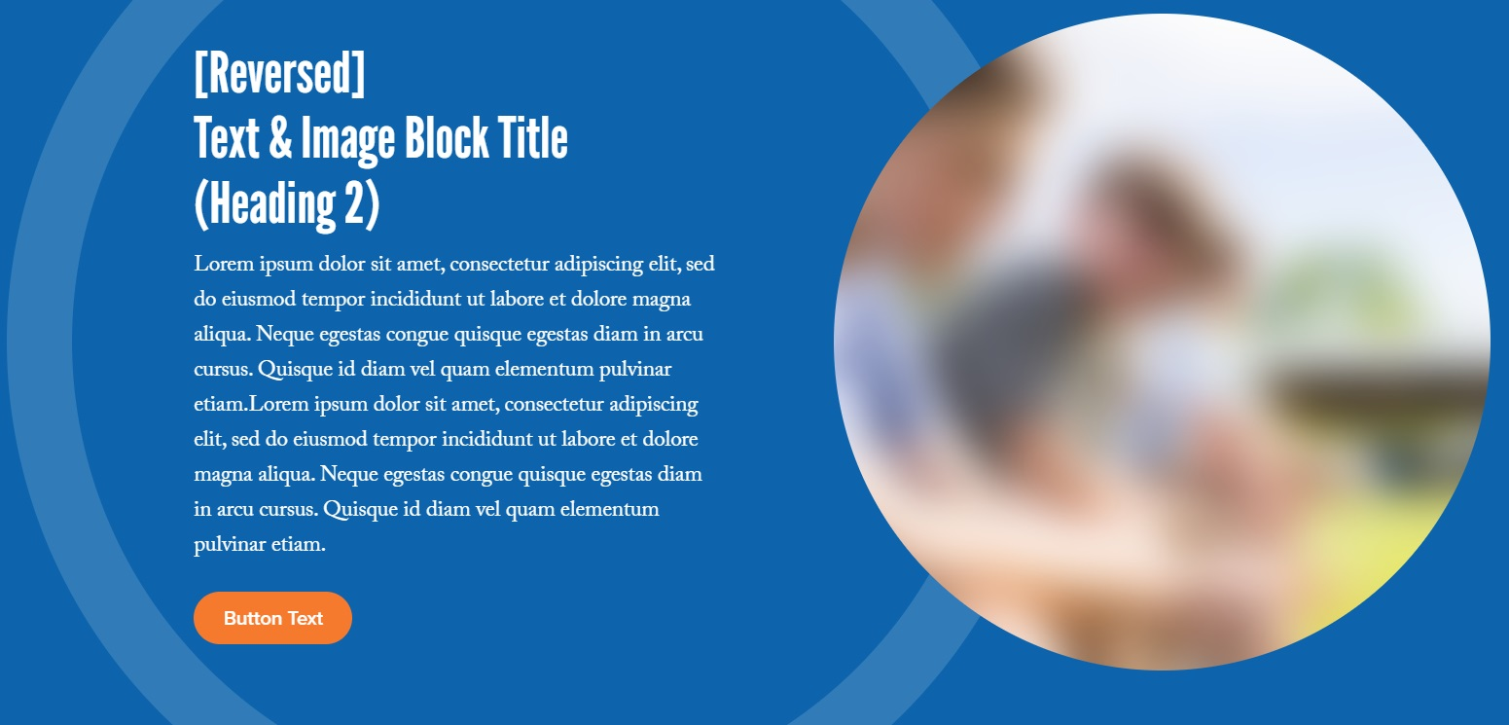
Frontend View - Reverse

Block 6: Text & Image ALT
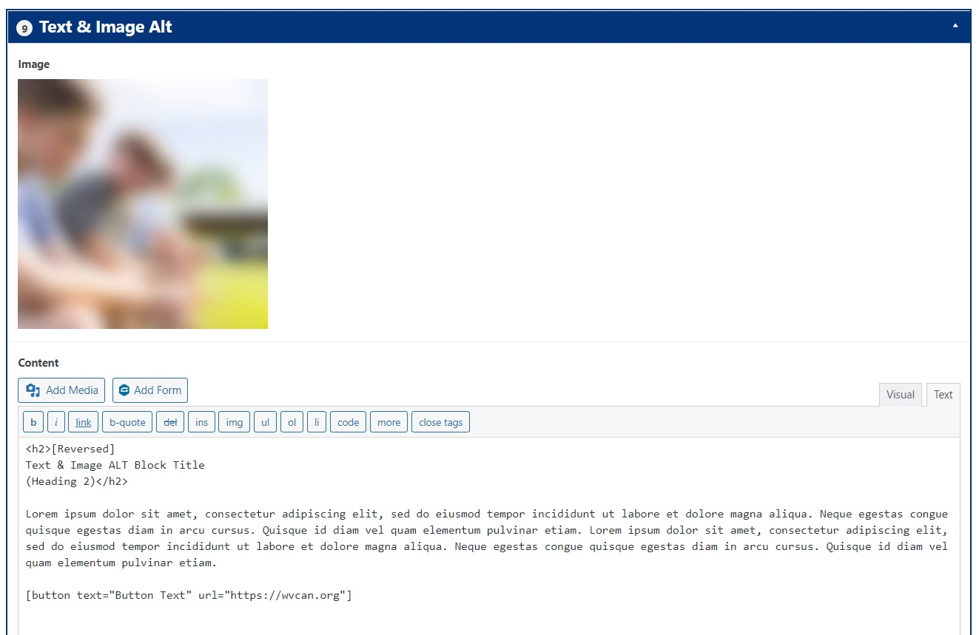
Dashboard View

This block differs from the previous one through the color of its background (white instead of blue). As with the other one, you can reserve the order of the elements by adding the reverse class modifier.

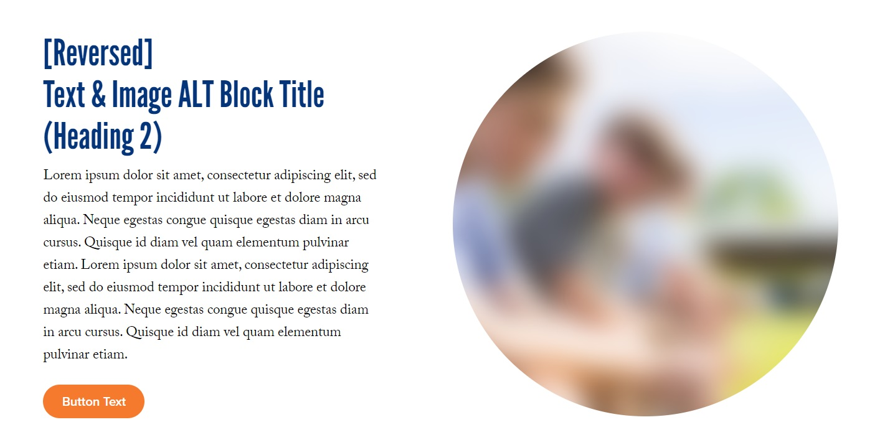
Frontend View

Block 7: Image Fullwidth
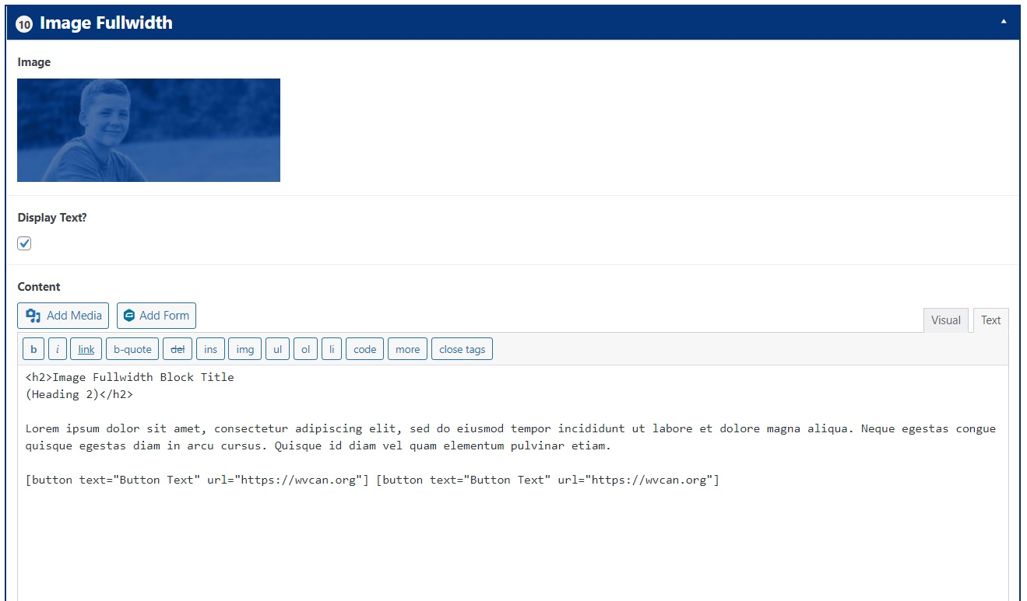
Dashboard View

This block allows you to use an image as a background, over which you can overlay text. Upload the image and then check the “display text” box. You can also add multiple buttons using the snippet mentioned above.

Image size should be 2560x1000px ___ .

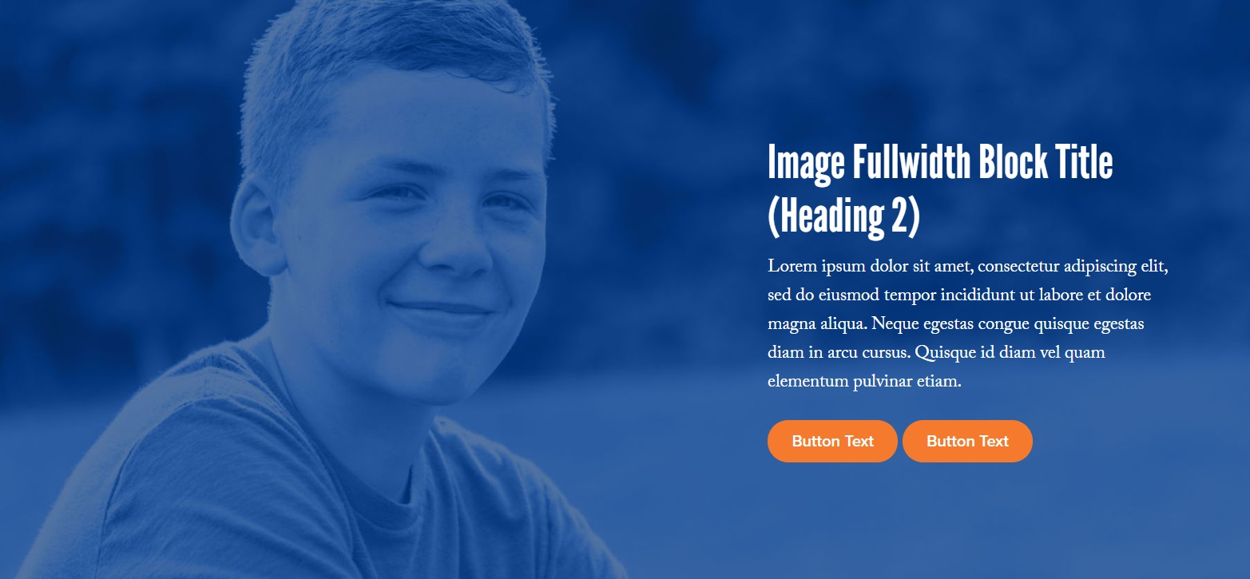
Frontend View

Block 8: Event
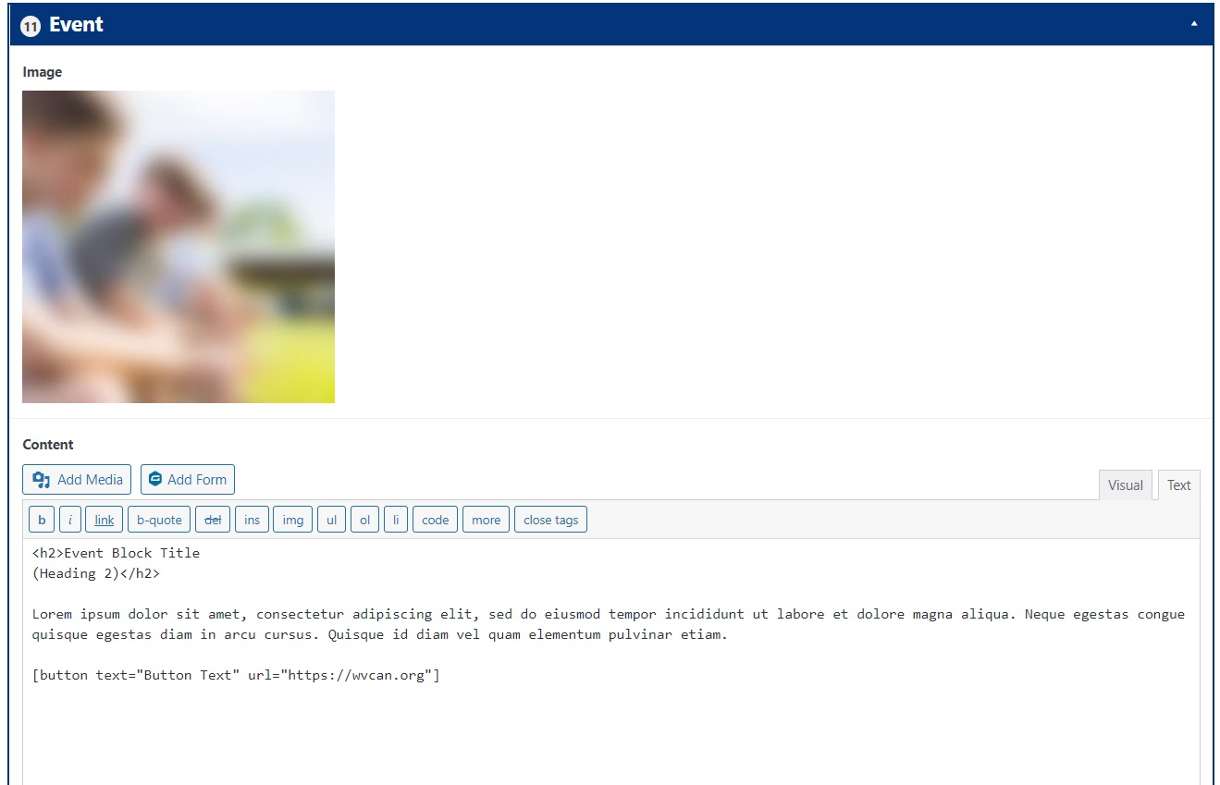
Dashboard View

The event block is a slightly modified text & image block. The main difference is that the image is squared instead of round. You can use the reverse modifier as needed.

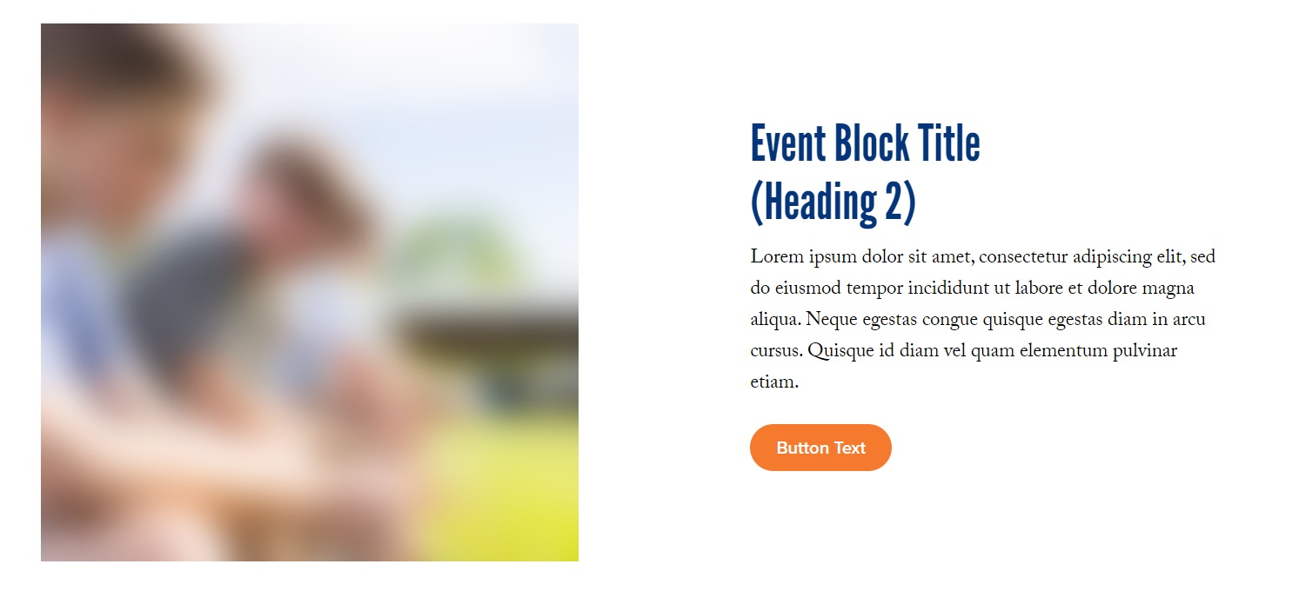
Frontend View

Block 9: Video
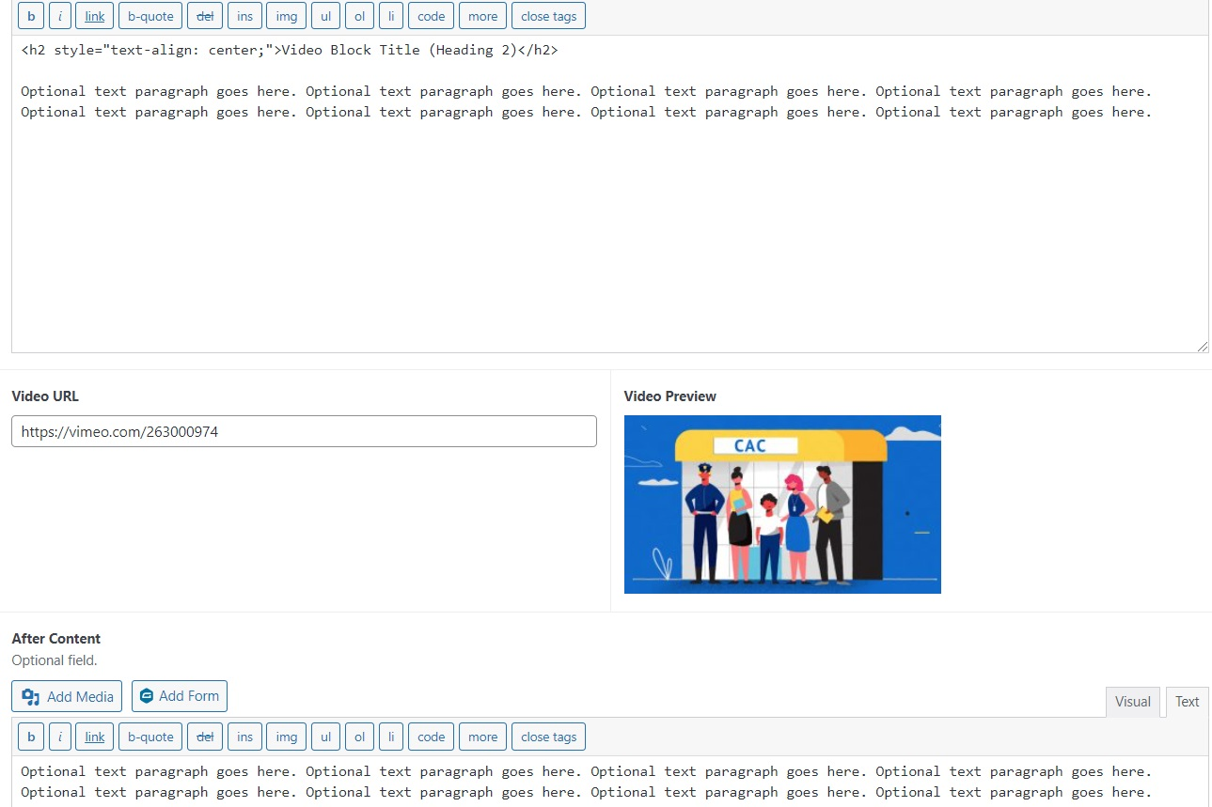
Dashboard View

The video block allows you to embed a video on a page. All you have to do is add the video URL to the designated field, as shown above.

Optional: You can frame the video with text (before and after). Make sure to copy-paste the heading snippet to maintain all styling, as shown above: <h2 style="text-align: center;">Video Block Title (Heading 2)</h2>

In the video block, for the button (added in the after content section, cut in the screenshot) copy-paste the following: <p style="text-align: center;">[button text="View Infographic" url="http://cac.proofbrandingdev.net/wp-content/uploads/2021/10/CAC-infographic.png" class="swipebox"]</p>

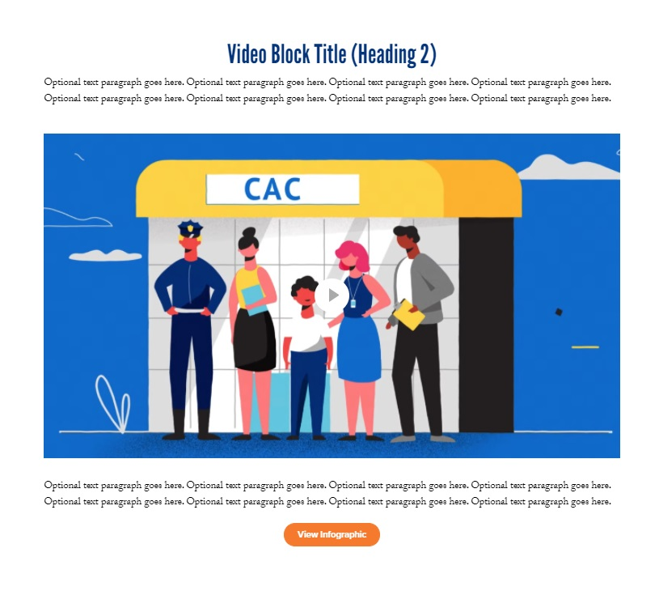
Frontend View

Block 10: Accordion
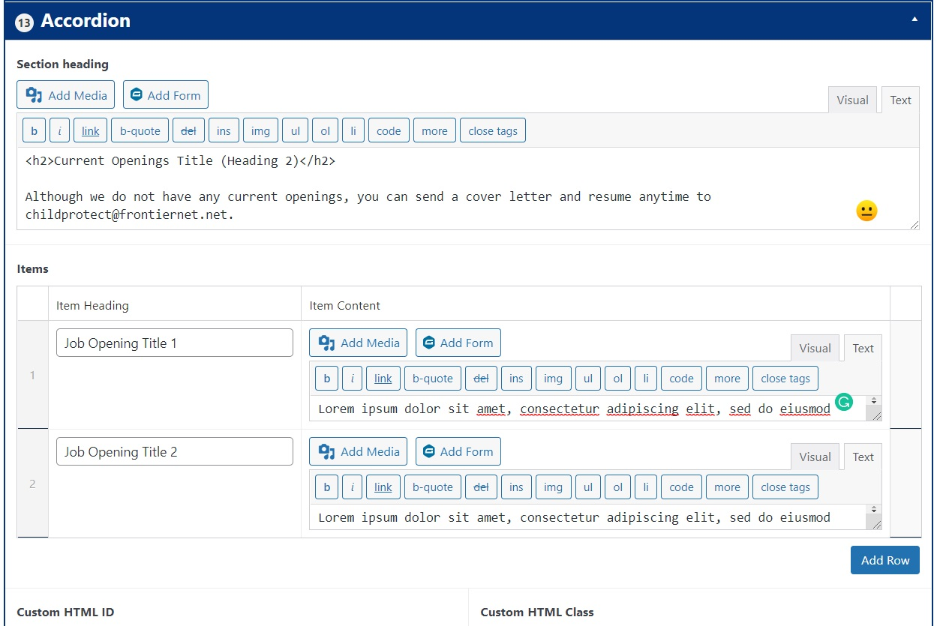
Dashboard View

The accordion block allows you to add accordion-style job openings or Q&A elements that need to be clicked by the user to expand. Add the question/job title to the item heading section, and the corresponding text to item content.

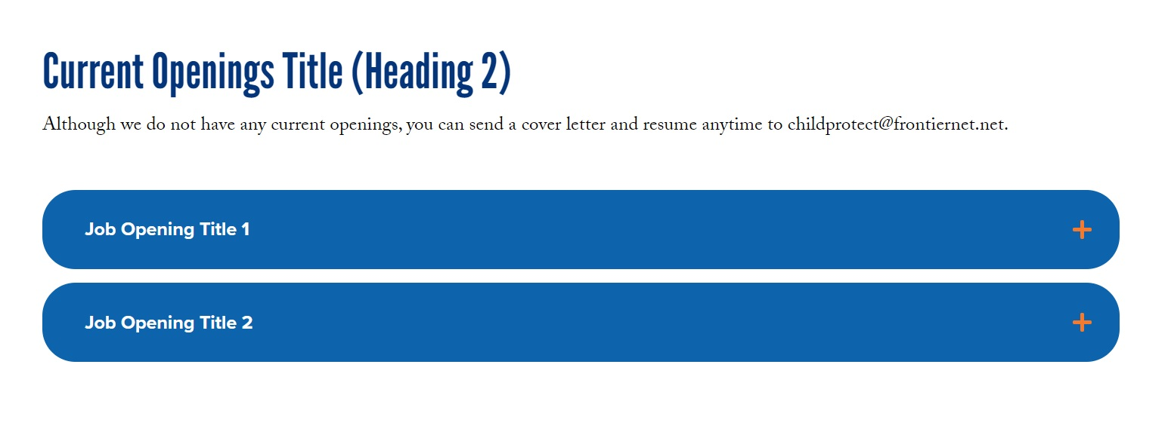
Frontend View

Block 11: Column (2, 3, 4, repeating)
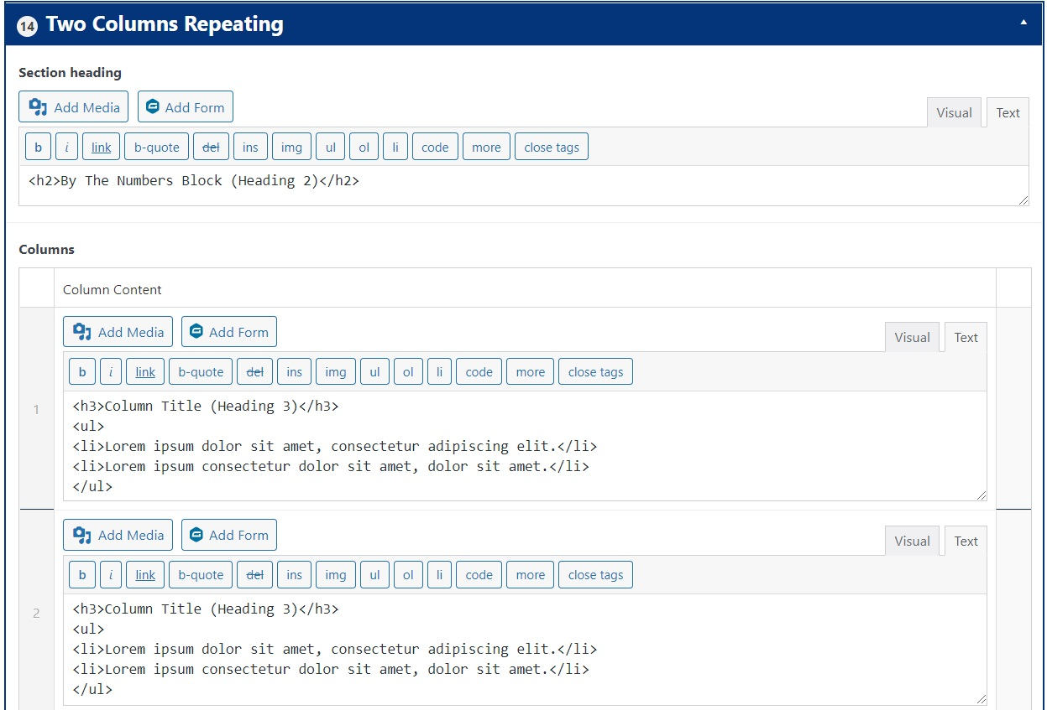
Dashboard View

With this block you can break down information in two, three, or four columns & multiple rows. You can add a section heading, with centered text above the columns.

Each column has a title marked by an <h3> tag followed by a list, where we use <ul> for the indent and <li> for the list elements.

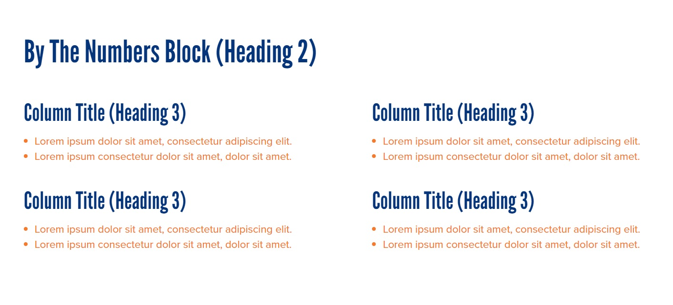
Frontend View

Block 12: Contact
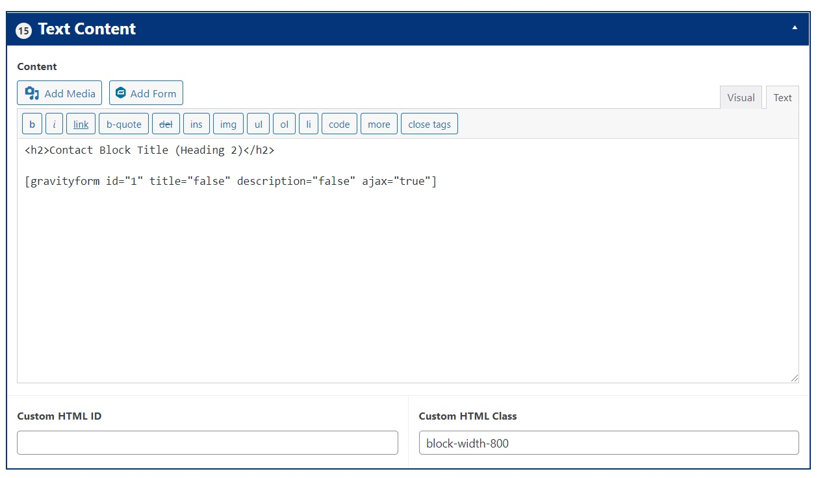
Dashboard View

To add a contact form to one of your pages, add a text block, type in your section heading, and copy-paste the following:

[gravityform id="1" title="false" description="false" ajax="true"]

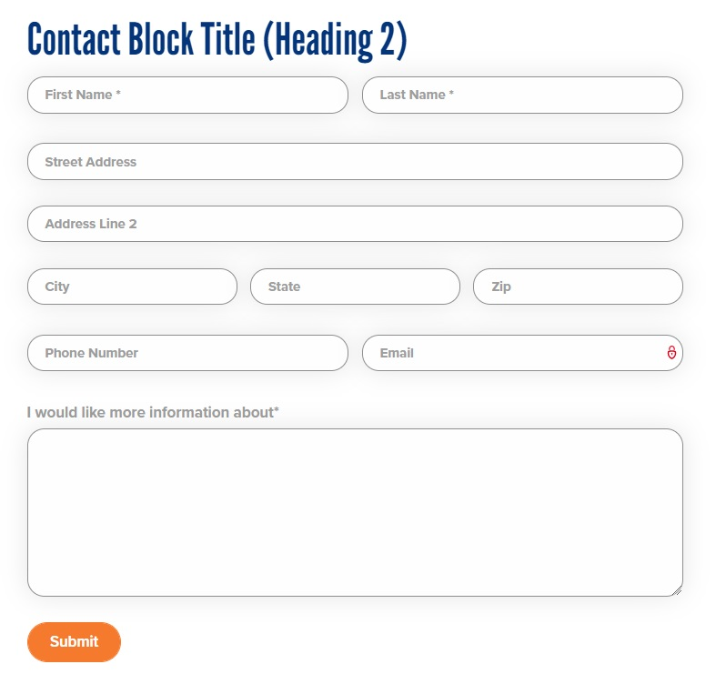
Frontend View

Block 13: Team
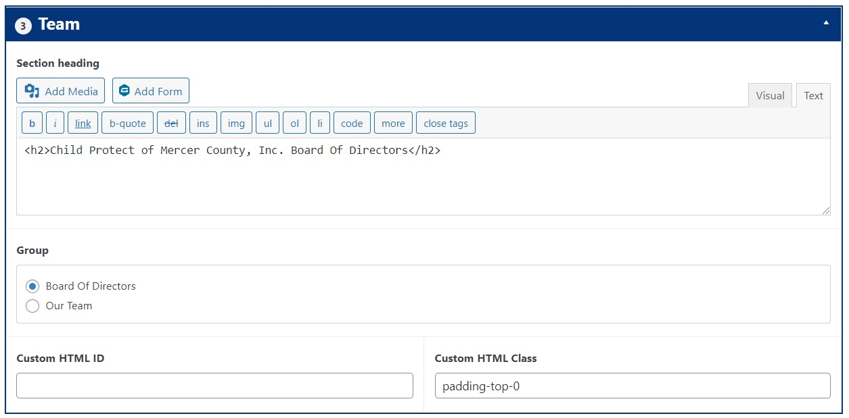
Dashboard View

To use the team block, all you have to do is add a section heading and then check the box for the group you want to feature. That group is populated with the information you add via the team members section (see above). This example also uses a modifier eliminates the block’s top padding.


Frontend View

Modifiers: Custom Classes
Now that we covered all the blocks you can mix and match to create new pages and update existing layouts, it’s time to address the extra layer of personalization called custom HTML classes. With a dedicated fiel in the bottom right corner of every block, the HTML class modifies the existing block to make it even more unique. This is particularly useful when you want to create a page using the same blocks (for example, text or text & image) and you want to add some color or background variation.

In addition to modifying the block in and of itself, you can use custom classes to change the color of the headings. To do that, instead of <h2>text</h2>, use <h2 class=”color-orange”>text</h2>.

For your website, we’ve used the following classes:

reverse - inverts the order of the block’s elements (text & image)

bg-white - changes the block’s background color to white
bg-grey - changes the block’s background color to grey
bg-blue - changes the block’s background color to blue
bg-blue-light - changes the block’s background color to light blue

color-orange - changes the heading color to orange
color-blue - changes the heading color to blue
color-white - changes the heading color to white

text-center - align text center
text-right - aligns text right
text-left - aligns text left

block-fullwidth - ensures the block covers the whole width of the screen
block-width-1000 - change the width of the parent container. For example, when used with an editor block it will make the text column narrower
block-width-800
block-width-600

padding-top-0 - removes the block’s upper padding (spacing between two blocks)
padding-top-50 - limits the block’s upper padding to 50px
padding-top-100 - limits the block’s upper padding to 100px
padding-top-150 - limits the block’s upper padding to 150px
padding-bottom-0 - removes the block’s lower padding
padding-bottom-50 - limits the block’s bottom padding to 50px
padding-bottom-100 - limits the block’s bottom padding to 100px
padding-bottom-150 - limits the block’s bottom padding to 150px

Content Styling
If you’re new to WordPress, it makes sense to not know how to go about styling the text you add to the page. To make things easier, here’s a breakdown of the most important features the WordPress text editor has to offer:

<b></b> - bold
<i></i> - italics
link - hyperlink
<blockquote></blockquote> - quote
img - adds image from a links
<ul></ul> - unordered list
<ol></ol> - ordered list
<li></li> - list item

<h1></h1> - heading 1 - one per page, used on the hero
<h2>/<h2> - heading 2 - standard page heading
<h3></h3> - heading 3 - subheading, good to use when adding lists

